1. 'ALEXA and | should be of same height and same alignment.

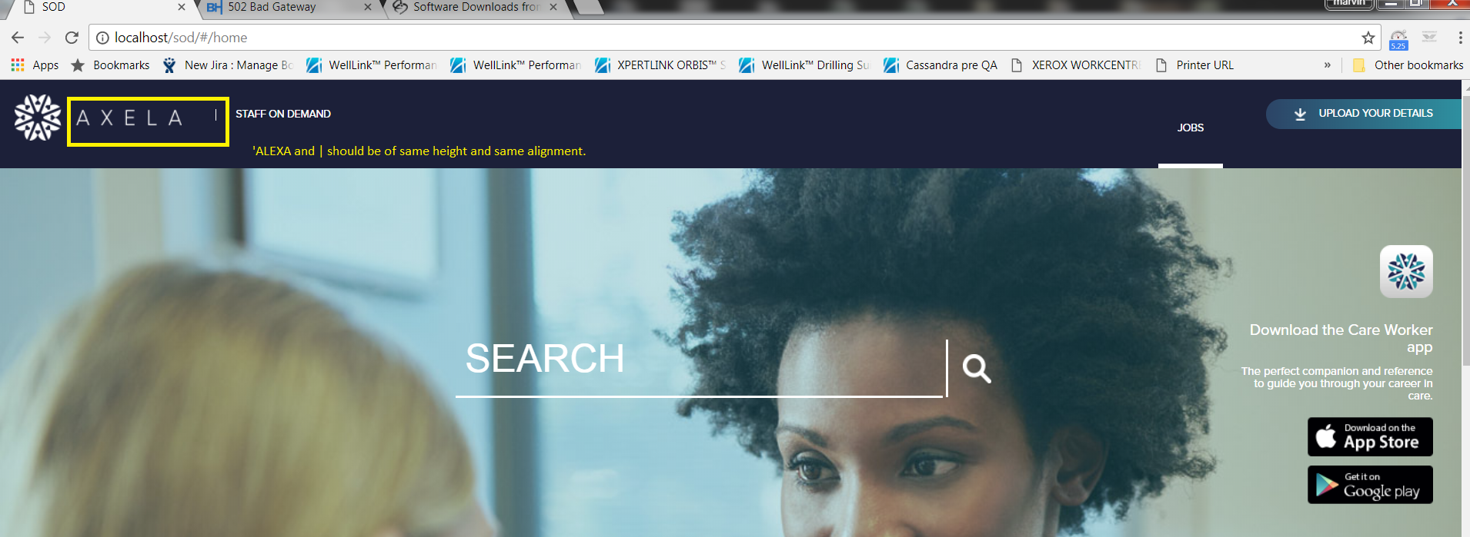

STAFF ON DEMAND should ne middle aligned with Logo and | symbol

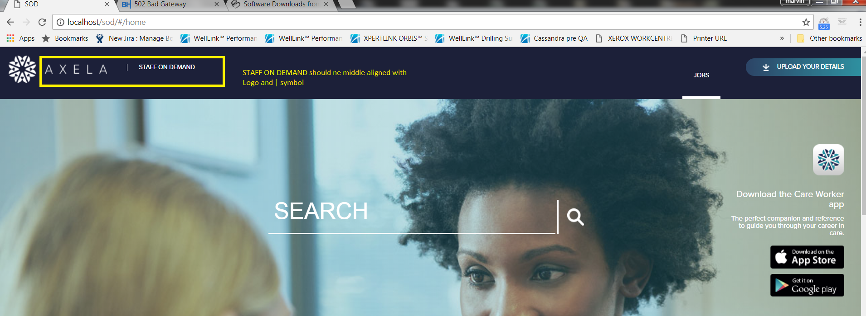

JOBS should be middle aligned with UPLOAD YOUR DETAILS

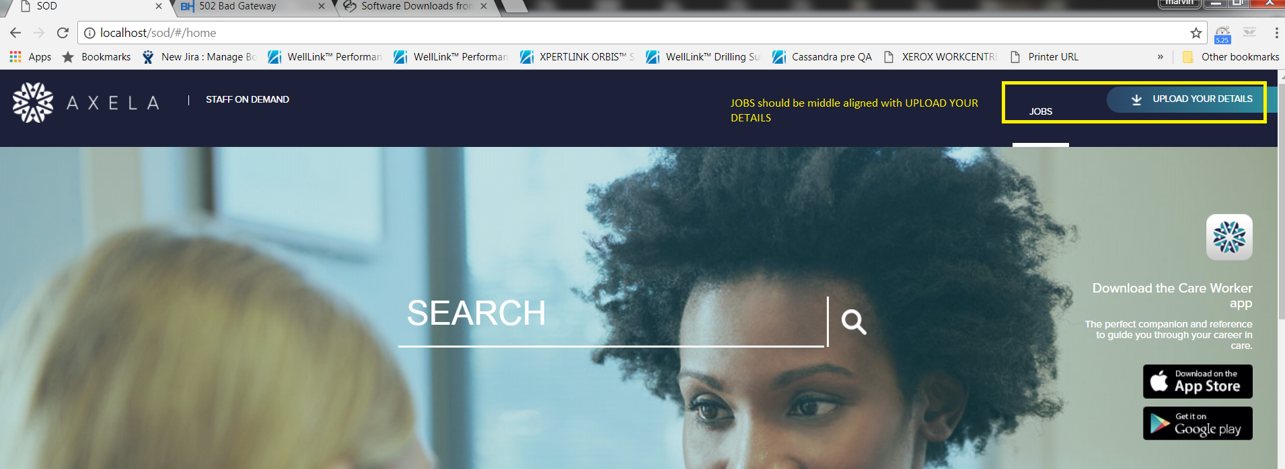

Text wrapping should be exactly similar to the provided screenshot. 'Download the' should be in first line and 'Care Worker app' should be in the second line. 'The perfect companion' text should also be wrapped similarly

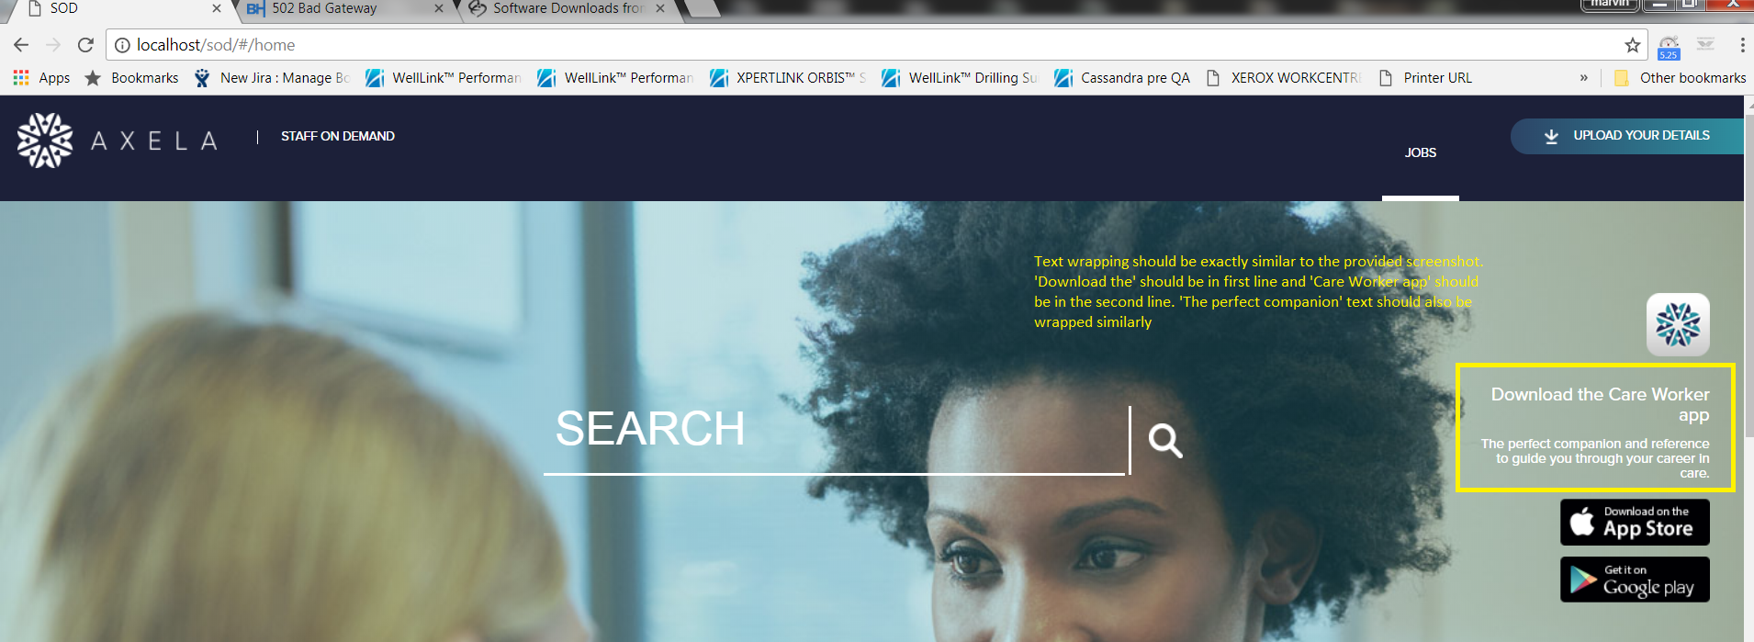

Filter text should be uppercase (capital letters) always

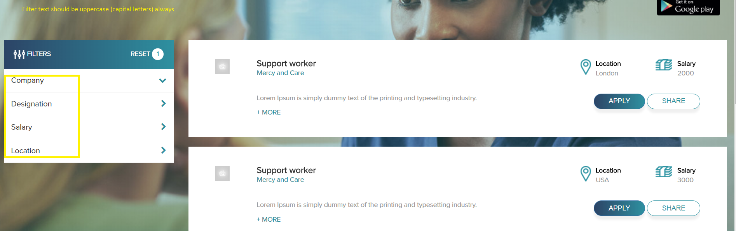

Gradient effect should be provided for builsh-green image where background image meets buish-green image.

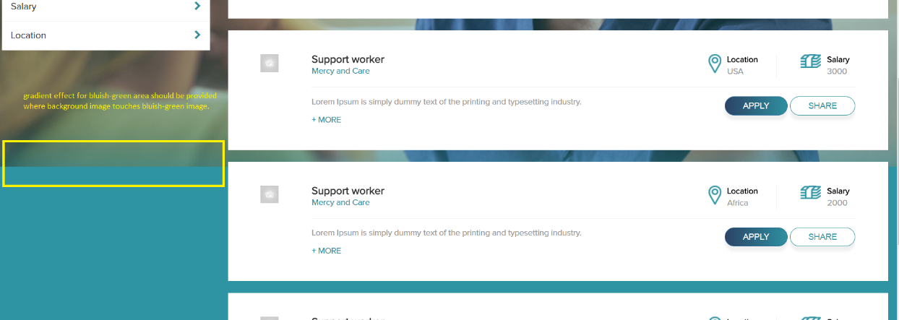

+MORE should be shown at right corner of description area not on left corner. It should be exactly as shown in provided design document

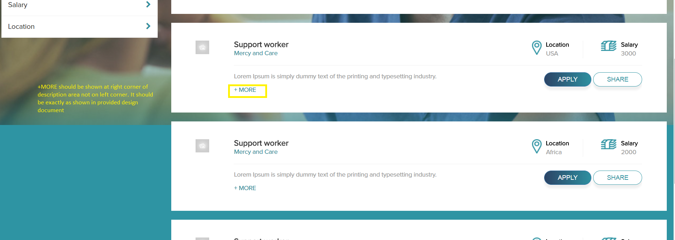

Navy blue area is missing at end of page.

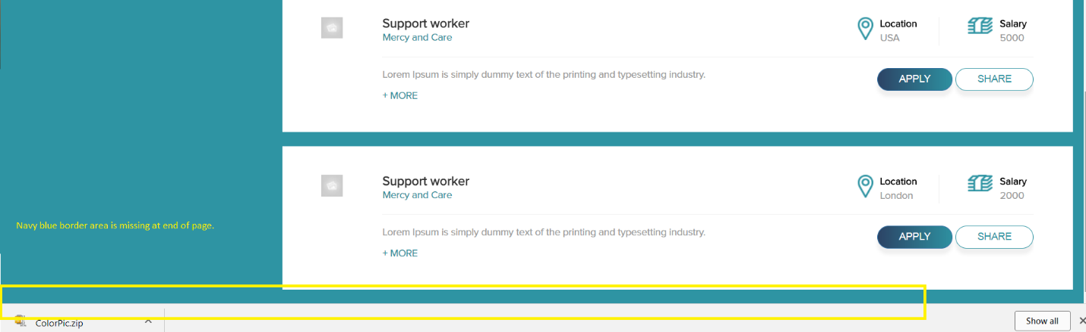

The horizontal and vertical lines should meet each other. There should not be missing pixel space between them

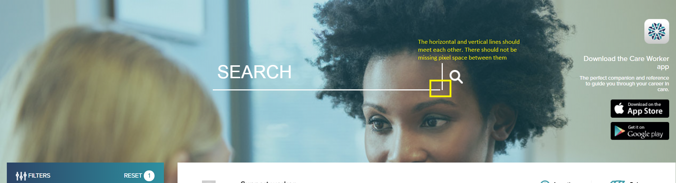

white border under search symbol is missing

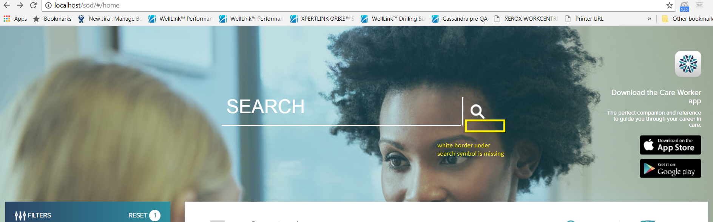

While entering search text, the text should be white color

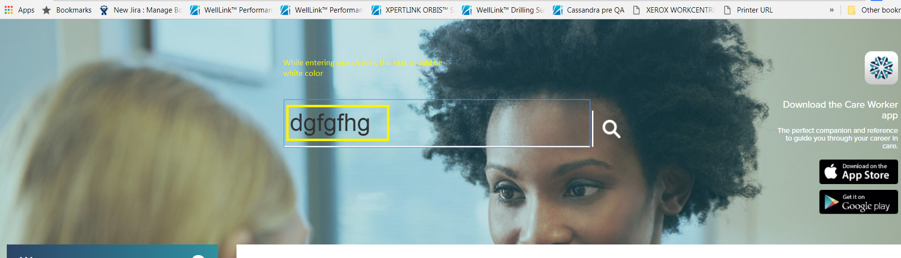

RESET should be shown only when any filter item is selected.

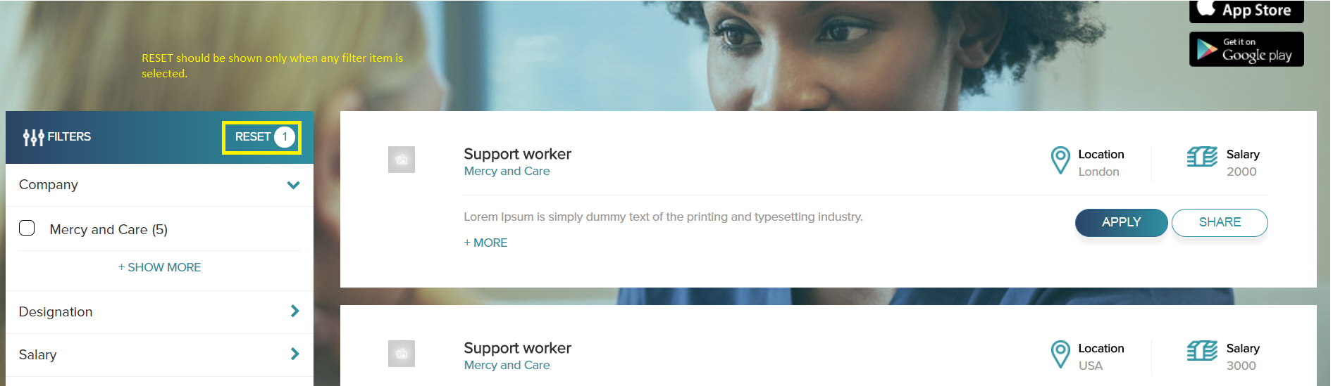

Filter number should be aligned in same line as (side arrow) >

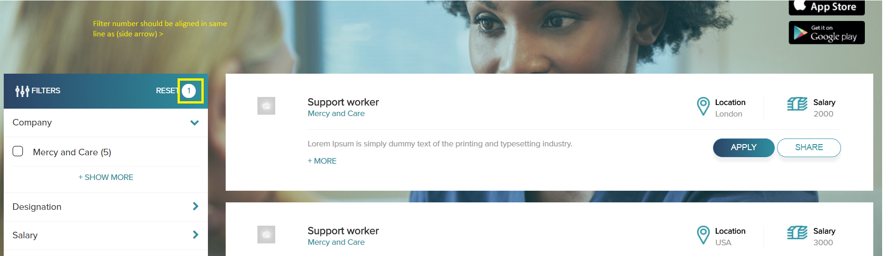

No. of filters selected should be in bold. 1,2 ..etc should be in bold.

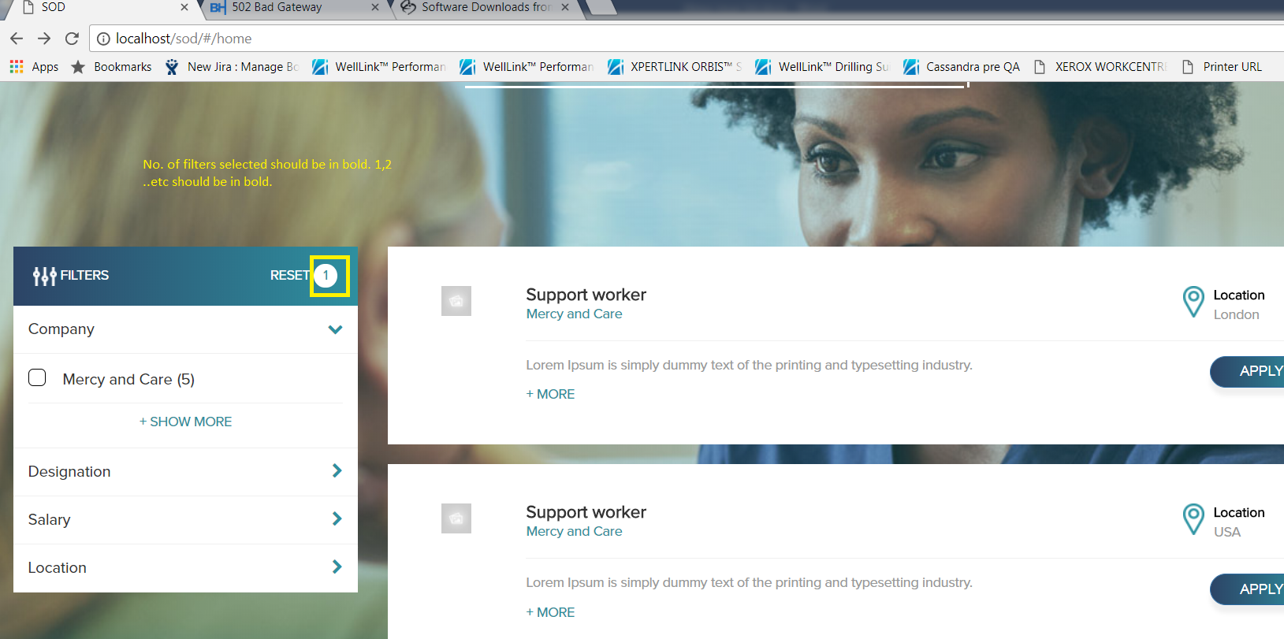

The number should be shown only if there are more than 1 filter items in a main filter

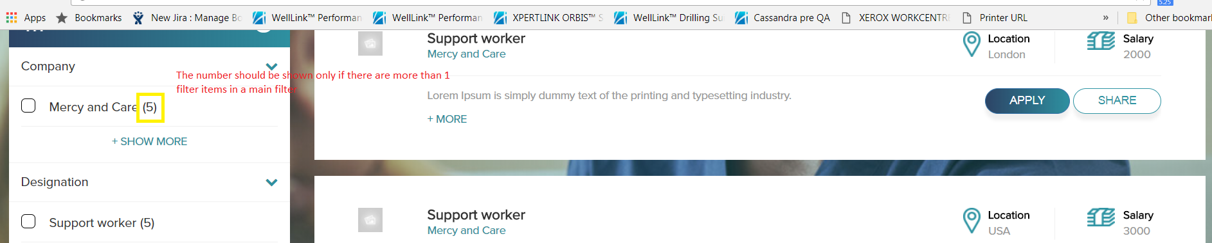

Filter item number should be on right side aligned to top/side arrow.

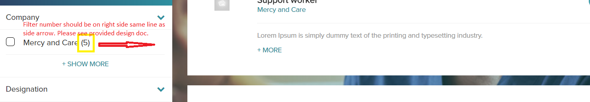

Filter number should not have ( ) brackets.

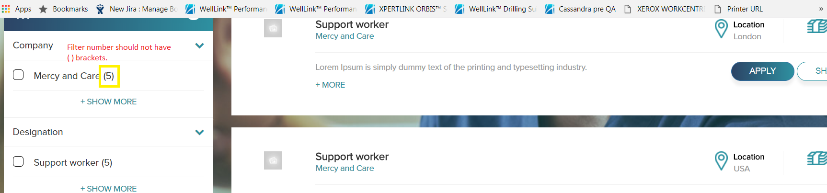

Filter items should be in uppercase (capital letters)

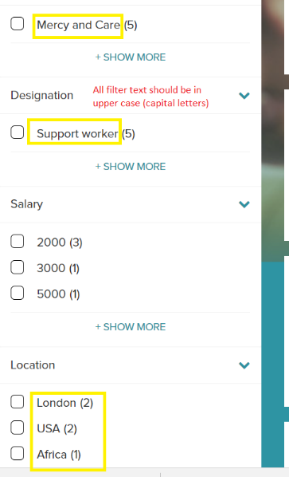

+ SHOW MORE should be aligned similar to filter items as shown in provided design document.

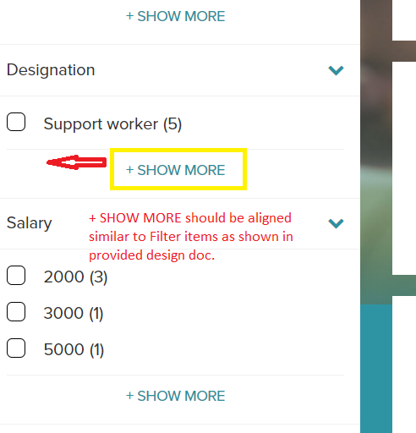

When filter item is selected, filter item name and number should also chnage color to exact ( #469dae or bluish green) color.

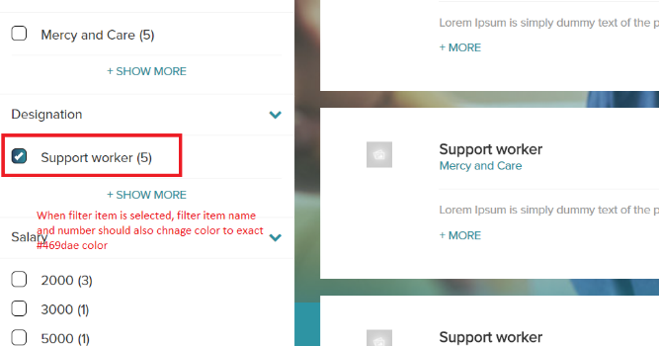

When main filter item is expanded, the down direction arrow should change to up arrow.

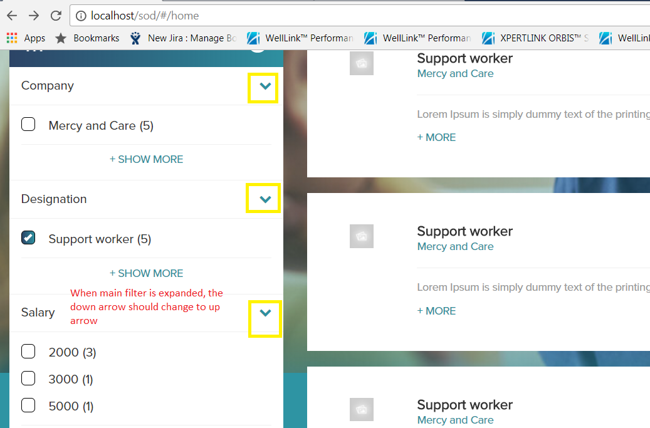

Description text header should be available for different description sections as shown in the design doc.

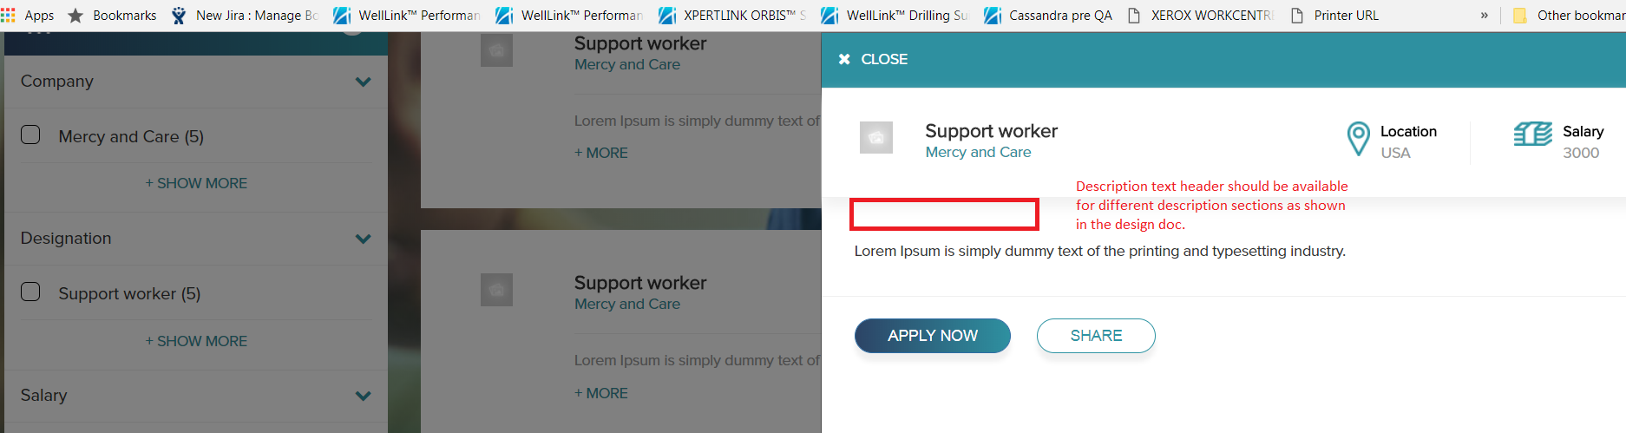

Vertical border between Email and telephone sections is missing.

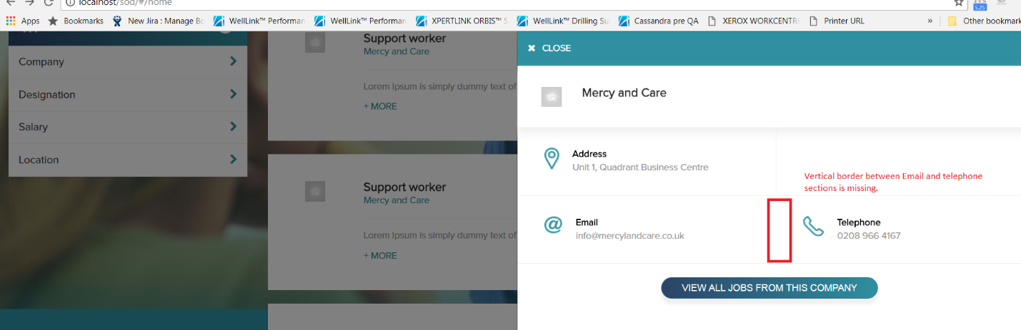

The font style and width between letters are different. This should be exactly same as provided design document.

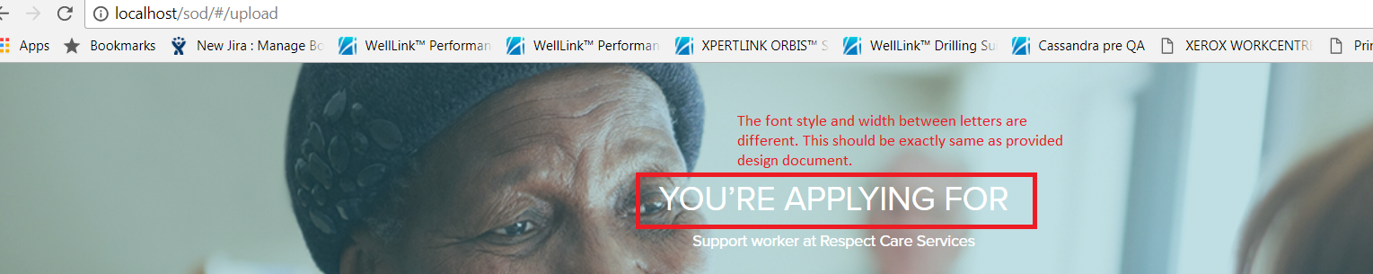

The job and description should be pulled from search text and underlined when page is displayed.

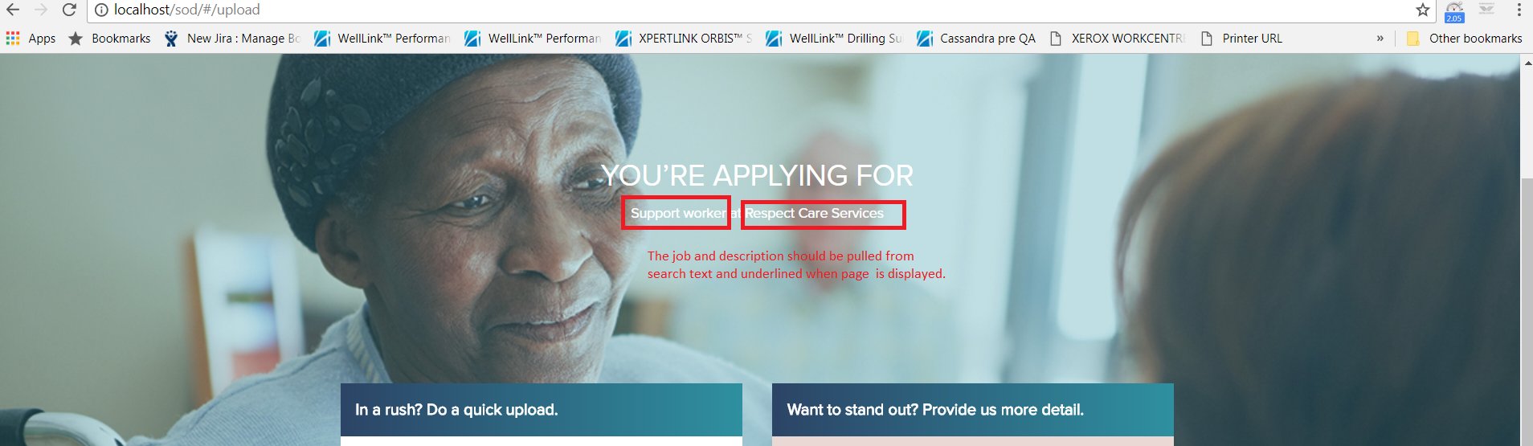

X - close button with round border is missing.

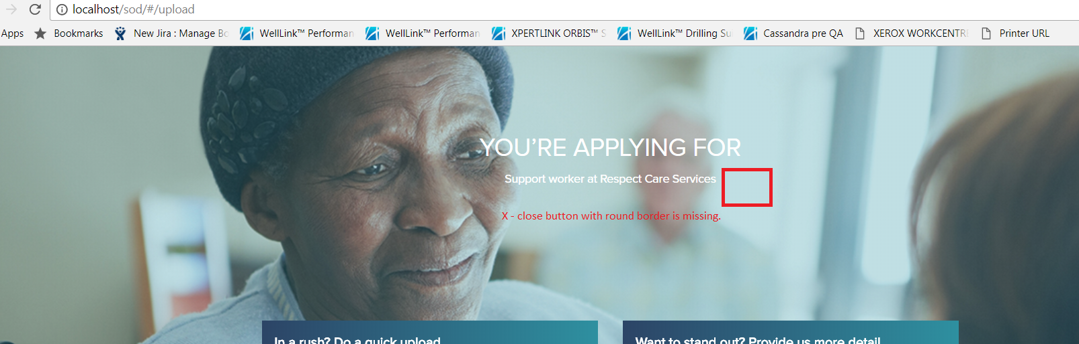

Search functionality on top banner is missing. This should be available on all pages except main page.

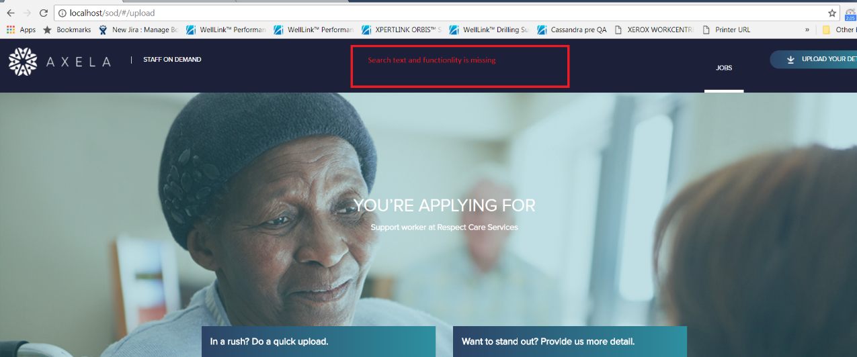

Blue banner with search and all items are missing when search result page is scrolled down. The banner should be available always.

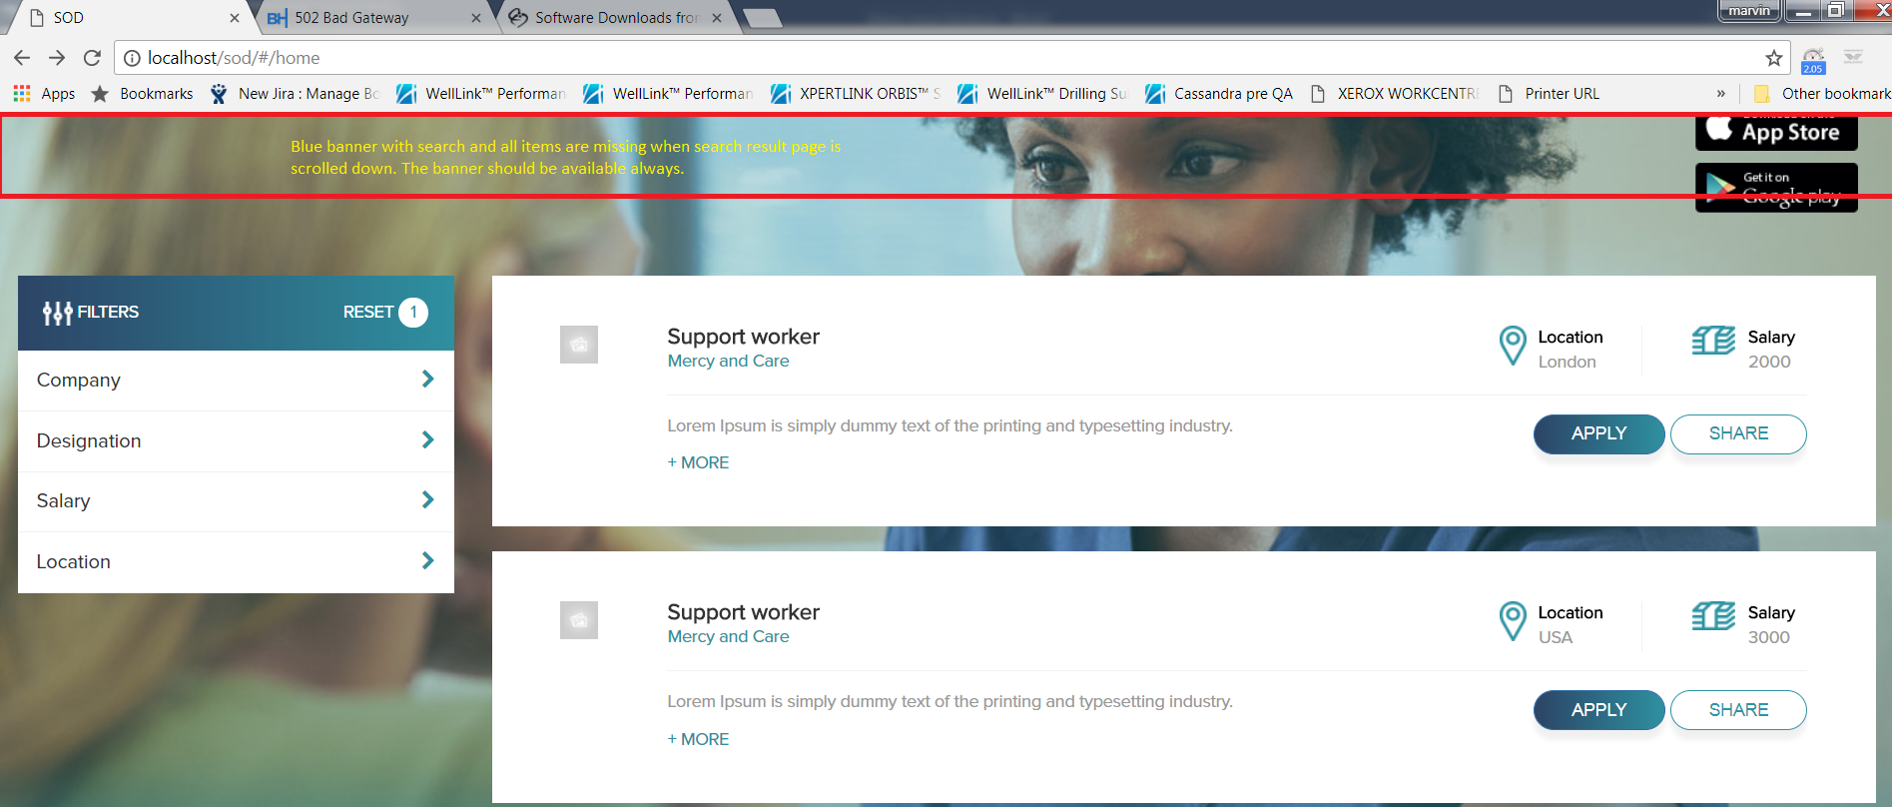

icons and text should be corrected as shown in design doc provided

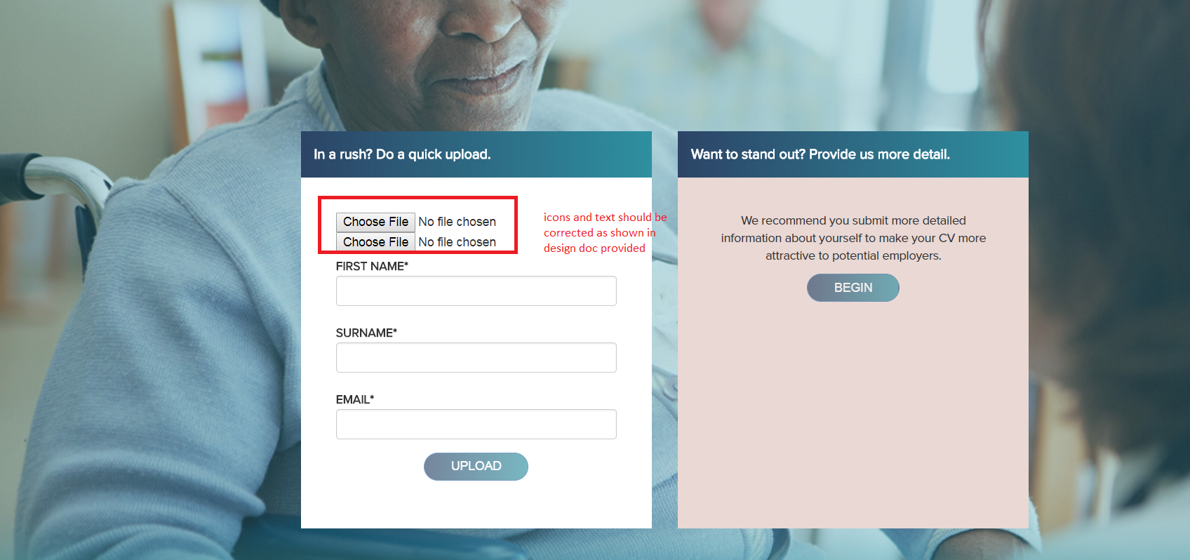

Headers for both areas should be aligned to icons in ‘quick upload’ screen.

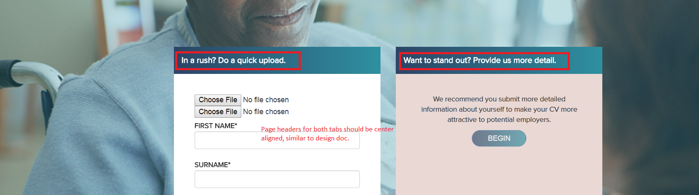

The text area, validation and UI should be exactly similar to design doc provided.

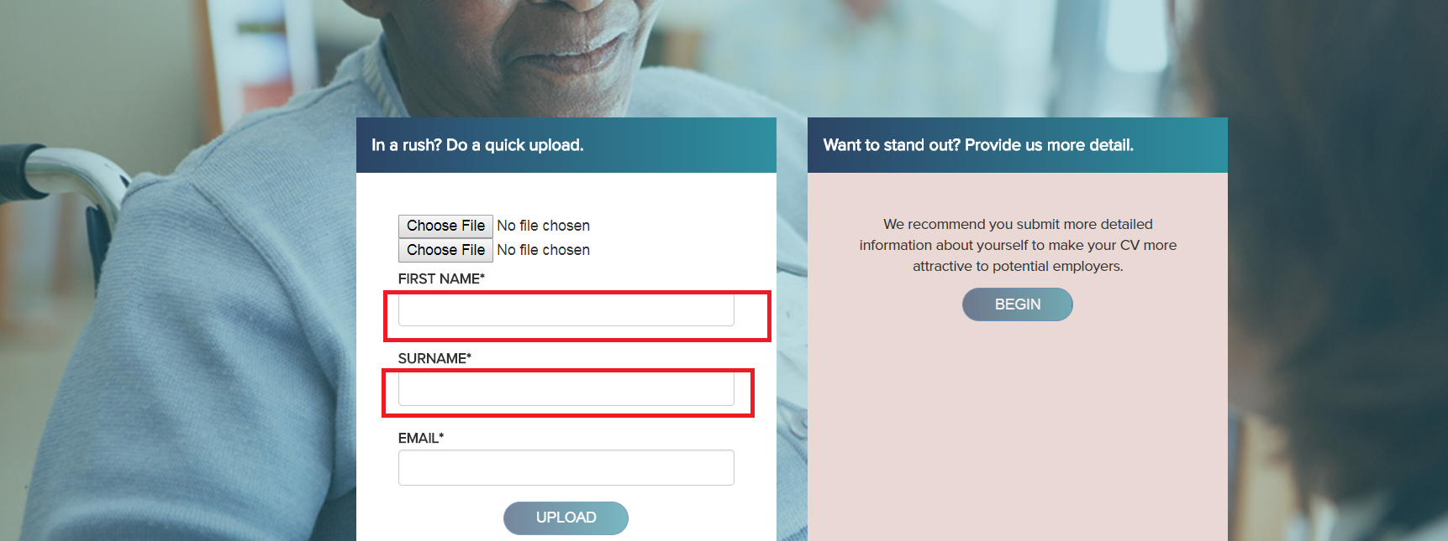

The buttons are currently light colored. They should be displayed exactly as in design document.

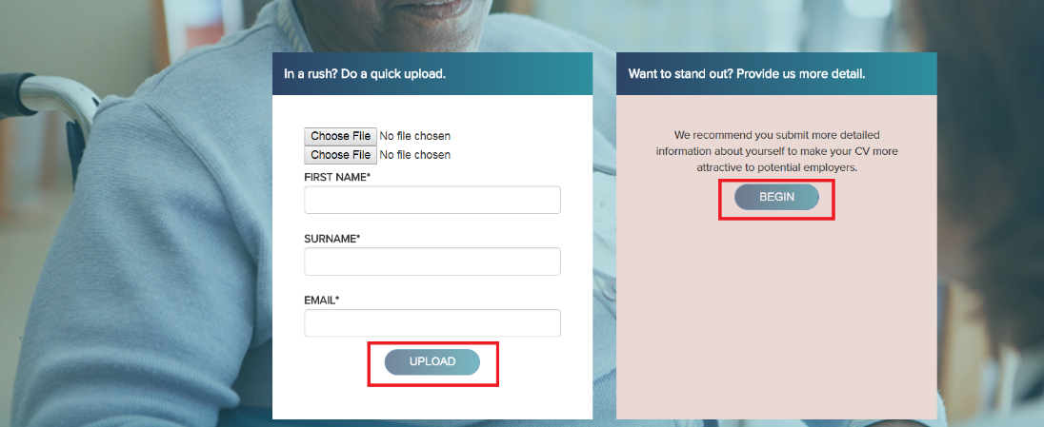

We recommend text and button should be aligned at center of light brown area. It is currently top aligned. This should be exactly as in design document.

